Assignment: module -5 Network Fundamentals and Building Networks

Section 1: Multiple Choice
1. What is the primary function of a router in a computer network?
a) Assigning IP addresses to devices
b) Providing wireless connectivity to devices
c) Forwarding data packets between networks
d) Managing user authentication and access control
ANS: Forwarding data packets between networks
2. What is the purpose of DHCP (Dynamic Host Configuration Protocol) in a computer network?
a) Assigning static IP addresses to devices
b) Resolving domain names to IP addresses
c) Managing network traffic and congestion
d) Dynamically assigning IP addresses to devices
ANS: Dynamically assigning IP addresses to devices
3. Which network device operates at Layer 2 (Data Link Layer) of the OSI model and forwards data packets based on MAC addresses?
a) Router
b) Switch
c) Hub
d) Repeater
ANS: Switch

Section 2: True or False
- A VLAN (Virtual Local Area Network) allows network administrators to logically segment a single physical network into multiple virtual networks, each with its own broadcast domain.
ANS: True
- TCP (Transmission Control Protocol) is a connectionless protocol that provides reliable, ordered, and error-checked delivery of data packets over a network
ANS: False
- A firewall is a hardware or software-based security system that monitors and controls incoming and outgoing network traffic based on predetermined security rules.
ANS: True

8. Describe the steps involved in setting up a wireless network for a small office or home office (SOHO) environment.
ANS: Setting up a wireless network for a Small Office/Home Office (SOHO) environment involves several key steps to ensure reliable connectivity, security, and scalability.
- Assess Network Requirements
Before purchasing equipment or configuring devices:
- Determine user needs: How many users and devices will connect
- Estimate bandwidth requirements: Based on activities
- Consider coverage area: Size of the office, number of rooms, and any physical obstructions
- Choose Appropriate Networking Equipment
Select hardware suitable for your needs:
- Modem: Connects to your Internet Service Provider (ISP).
- Wireless Router or Access Point Distributes wireless (Wi-Fi) signal.
- Switch For additional wired connections.
- Wireless Network Interface Cards For computers without built-in Wi-Fi.
- Physically Set Up the Network
- Configure the Router or Access Point
Access the router’s web-based setup interface (usually via a browser):
- Enter the router’s IP address (e.g., 192.168.0.1 or 192.168.1.1).
- Configure and Connect Client Devices
- On each device (laptop, phone, etc.), open Wi-Fi settings.
- Select your SSID and enter the Wi-Fi password.
- Test connectivity by browsing the Internet or accessing shared resourse
- Secure the Network
- Optimize Network Performance
- Test and Monitor the Network
- Check signal strength in different areas.
- Test Internet speed (e.g., using Speedtest.net).
- Verify security by ensuring only authorized devices can connect.
- Monitor traffic and logs periodically for unusual activity.

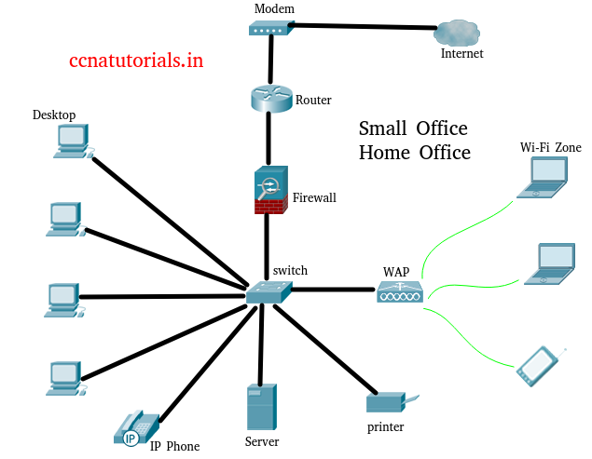

Diagram of a small office or home office (SOHO) environment:

Section 4: Practical
- Demonstrate how to configure a router for Internet access using DHCP (Dynamic Host Configuration Protocol).
ANS: Here’s a step-by-step demonstration of how to configure a router for Internet access using DHCP
Step 1: Physical Connections
- Turn off the modem and router.
- Connect the modem to the router’s WAN (Internet) port using an Ethernet cable.
- Connect your computer to one of the router’s LAN ports (e.g., LAN1).
- Power on the modem, wait 1–2 minutes, then power on the router.
Step 2: Access the Router’s Configuration Interface
- Open a web browser on your computer.
- In the address bar, type the router’s default IP address (usually one of these):
  - 192.168.0.1
  - 192.168.1.1
  - 10.0.0.1
- Press Enter.
- Log in with the default username and password (often printed on a label on the router).
Example: Username: admin, Password: admin or password
Step 3: Configure the WAN (Internet) Settings
- In the router’s admin menu, look for “Internet Setup,” “WAN Setup,” or “Network Settings.”
- Under Internet Connection Type, select DHCP (sometimes called “Dynamic IP” or “Automatic Configuration – DHCP”).
- Click Save or Apply.
Step 4: Verify the Internet Connection
- Go to the Status or Network Map page of the router.
- Check the WAN IP Address section — it should now display an IP address assigned by the ISP.
  - Example: WAN IP: 203.0.113.24
  - If it shows 0.0.0.0, restart the modem and router.
- Open a web browser and try visiting a website
  - If the page loads, Internet access is working correctly.
Step 5: Configure the LAN and Wireless (Wi-Fi) Settings
- Go to Wireless Settings:
  - Set SSID (network name): e.g., Office_WiFi.
  - Choose WPA2 or WPA3 security.
  - Set a strong Wi-Fi password.
- Go to LAN Settings (optional):
  - Ensure DHCP Server is enabled on the router for local devices.
  - This will automatically assign IPs (like 192.168.1.x) to computers and phones.
- Save and reboot the router if required.
Step 6: Test and Troubleshoot
- Check LAN IP: Your computer should have an IP like 192.168.1.2.
- Ping test:
  - Open Command Prompt → type ping 8.8.8.8 → press Enter.
  - Successful replies mean Internet connectivity is working.
- If no connection:
  - Restart modem and router.
  - Verify DHCP is enabled on the WAN interface.
  - Check cables and ISP service.
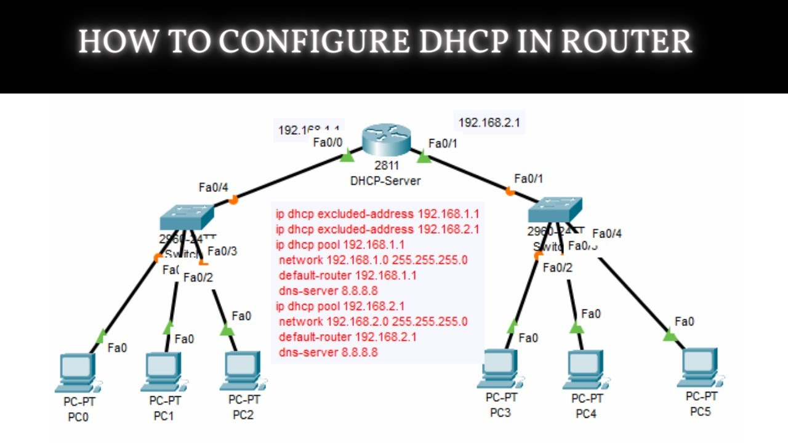

Section 5:
10.Discuss the importance of network documentation in the context of building and managing networks.
ANS: Network documentation is a critical component in building, managing, and maintaining any computer network — whether small (like a SOHO) or enterprise-level. It involves systematically recording all details about the design, configuration, devices, connections, policies, and procedures that make up the network.
1. Facilitates Network Planning and Design
- Proper documentation helps network administrators plan the layout and topology of the network before implementation.
- It allows for better capacity planning, identifying what equipment, cables, and IP addressing schemes are required.
2. Simplifies Network Implementation
- During the installation or upgrade process, well-prepared documentation acts as a blueprint.
- Reduces confusion and ensures that the actual setup matches the intended design.
3. Aids in Troubleshooting and Problem Resolution
- When a network issue arises, accurate documentation helps identify where the problem might be.
- For example, knowing which switch port a device connects to or the configured IP address range speeds up diagnosis.
4. Enhances Network Security
- Documentation includes records of user access controls, firewall rules, and security configurations.
- Makes it easier to review and audit security settings regularly.
5. Supports Network Maintenance and Upgrades
- When making changes (like adding new devices or upgrading firmware), documentation ensures changes are made consistently and safely.
- Minimizes the risk of disrupting other services
6. Improves Team Collaboration and Knowledge Transfer
- Network documentation ensures that information is not dependent on one individual.
- Encourages standardization and consistency across the organization.
7. Assists in Asset and Inventory Management
- Documentation tracks all network devices (routers, switches, access points, cables, etc.) along with serial numbers, IPs, and firmware versions.
8. Ensures Compliance and Audit Readiness
- Many organizations must comply with standards (e.g., ISO, PCI-DSS, HIPAA).
- Avoids penalties during audits
9. Enables Disaster Recovery and Business Continuity
- In the event of a failure, natural disaster, or cyberattack, documented network configurations and topology maps are vital for restoration.
10. Types of Network Documentation
Effective documentation usually includes:
- Network topology diagrams (physical and logical)
- IP addressing and subnetting plan
- Device inventory list
- Configuration files and backup procedures
- Cabling layouts and labeling schemes

